Introduction to Stenton
Show What You Know (p. 33)
- List at least 3 of the jobs, or occupations, that James Logan held:

- How did James Logan help make the colony of Pennsylvania larger?

- The labor force at Stenton was made up of and .

- What is oral history? Who and what do we learn about from oral history at Stenton?

5. Deborah Logan wrote about Stenton and the Logan family in her diaries and letters. How does that help us today?

6. What are some of the ways your family saves family history?

7. Think and discuss:
• If James Logan had stayed in England, do you think he would have had the kind of life and home he had in Pennsylvania? Did his connection with the Penn family help him? If so, how?
• Do you think everyone coming to Pennsylvania had the same opportunities as Logan? Who did or did not?

Stenton Previsit Activity #1
Working for William Penn (p. 34)
A Matching Activity

Introduction:
In 1699, James Logan’s life changed. He left his schoolteacher and shopkeeper jobs behind him in England, and sailed to America with his new boss, William Penn, who had founded a new colony of Pennsylvania in 1681. Logan became Penn’s secretary, an important assistant who was given many important tasks to do for the colony’s leader. The following quotes from letters, written by Penn or other Penn family members, mention many of the different jobs that Logan was given.

See if you can match the task to the different roles he held.

Instructions:
Write the correct letter (or letters) next to the quote that best describes the job Logan was asked to do for the Penns. There may be more than one job described in a quote.

A. fur trader E. tax collector
B. merchant (shopper) F. bill payer/accountant
C. construction supervisor G. land & real estate salesman
D. surveyor H. landlord (rent collector)

“Get in [rent payments]…-William Penn
“….sell lands…” -William Penn
“Get in the taxes….” -William Penn
“[I] must desire thee to send the two pair of pewter candlesticks, some great candles and a dozen pounds smaller [candles]….Call Betty Webb to thy assistance: let her send two mops to wash house with….I would have thee buy a firkin…of good butter, also cheese and candles, etc. for winter….” –Hannah Penn, William Penn’s wife
“Pay off all my notes [bills], settle my accounts…..” –William Penn
“….Get my two mills finished…- William Penn
“Cause all the province [colony]…to be resurveyed…”-William Penn
“…oh, …that thou [you] would do all that is possible to master furs and skins for me, but bears especially.” -William Penn
“Pray send me two or three smoked haunches of venison [deer meat] and pork, get them from the Swedes; ….send up for cider, what barrels thou canst get in town;...and by all means chocolate, if to be had…twelve bottles of Madeira wine, and as many of the white.” -William Penn

Stenton Previsit Activity #2
The Business of Trade (pp. 35-36)

Introduction:
Trade was an important part of life in the colony of Pennsylvania. William Penn hoped that with a lot of trade, the colony would grow and earn money, and become a successful place for people to live and work.

James Logan was very involved in trade during his life. He earned a lot of money in the fur trade, paying trappers to trap animals for their fur coats, or pelts, and skins and then shipping the cleaned furs and skins to merchants in England. He also bought goods from England and had them shipped over to Philadelphia, where he would sell them. He loaded large wagons called Conestoga wagons, and shipped goods to areas on Pennsylvania’s western frontier. And he traded goods with Native Americans in return for land. He also gave them trade goods during treaties, or meetings and negotiations.

On the next page you see a copy of a page from James Logan’s ledger, [LEH jer] a record he kept of what he was buying and selling. It is in old fashioned handwriting and is hard to read. Below it is written out for you to read more easily. See if you can answer the questions below about trade.

Questions:

1. What kind of animals were hunted for their furs and skins in colonial Pennsylvania? What is a fisher?

2. What kinds of goods were being purchased for the Indians during treaty meetings?

3. What were some of the food items James Logan bought for his house?

4. Why do you think Logan was buying so much wood?

- From what countries were James Logan and his fellow businessmen buying and selling things?

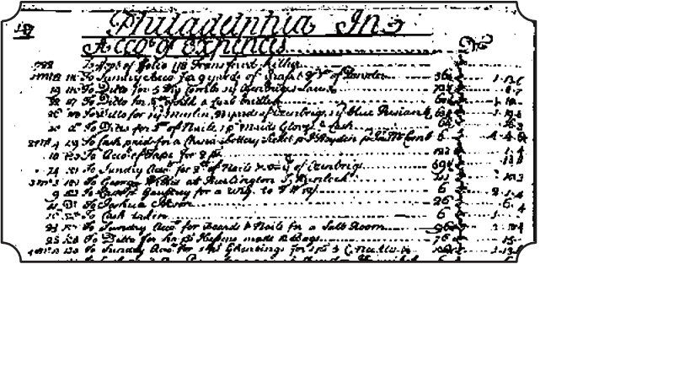

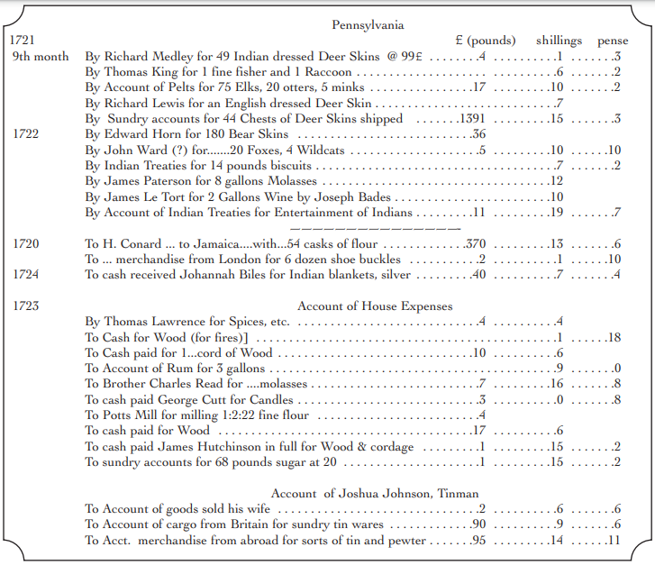

Postvisit Activity
Stenton Reporter Assignments (pp. 40-41)

Teacher Note: There are 7 different types of newspaper features listed below for your student reporters. You may choose to assign several children to each type of feature, or have students work in groups to complete the 7 assignments. Read over the assignments carefully with students before your site visit, so that they understand their own particular “fact-finding” mission. They will use the notes from their visit to complete their news- writing assignment as a post-visit activity.

1. Travel writer’s account
Describe your class trip to Stenton. Use lots of details so that your readers will know all about your trip.
a. Who, what, where, when, why, how
i. Who went on the trip? [example: Mrs. Robinson’s fifth grade class], who did you meet there, who was your guide? When was your trip? Why was your class going? (what are you studying in social studies?) How did you get there?
ii. What is Stenton? Where is it located? When was Stenton built? Who built it? Who lived there?
iii. Did you enjoy your visit? Would you recommend it to others? Why

2. News Story
Describe an important event or activities that took place at Stenton in the past. Remember to record the facts: Who, what, where, when, why, how. --

3. Interview
Pretend you have traveled back in time to the days when James Logan and his family lived at Stenton. Or perhaps you’ve traveled back to the days when Dinah was tending the house. You have been given a chance to talk to one of these people from the past. Think of questions you would ask one of them. (Examples are: Mr. Logan, why did you own so many books? Or, what was it like working for William Penn? Or maybe you’d ask Dinah how long she worked at Stenton, and when did she request her freedom? Why did she decide to work at Stenton after she was free? What did she do when British soldiers came to Stenton during the Revolutionary War?) Write
the interview as if you and your interview “subject” are talking back and forth.

4. Illustration
Although most newspapers have photographs to illustrate events and show what people look like, drawings and sketches are also used. Draw a quick sketch of something that will help show what your visit to Stenton was like. You might choose to sketch part of a room in the house, one of the family members, or enslaved and indentured servants, or something you did while visiting. Finish your drawing when you return to your classroom.

5. Editorial
Pretend you have traveled back in time to the days when the Walking Purchase took place. You are the editor of a Philadelphia newspaper. Choose a side – James Logan or a Lenape leader — and explain your views on how the land was taken. State your opinion and try to explain why you are right. Remember to listen carefully to the tour guide to gather notes that will help you write your editorial back in the classroom.

6. Comics
Take notes about an event or person or persons that you learn about at Stenton. Using your notes, draw a comic strip with captions (bubbles that show thoughts or spoken words) to tell about that event or person.

7. Poem
Take notes about an event or person/persons that you learn about at Stenton. Using your notes, write a poem back in the classroom to tell about that event or person.

