**Introduction to Belfield and**

**La Salle University Art Museum**

**Show What You Know**

1. What is a portrait?
2. Name three types of portraits that you will see on your visit to La Salle University Art Museum.
3. Who was one of the most important portrait painters of the 19th century?
4. Name three important people that he painted.
5. What else did he do?
6. Think and discuss:

a. Why are historical portraits important?

b. How do we make portraits and self-portraits today? Specifically, what changes in technology allow for us to make portraits differently now?

c. Are portraits still as important as they were in the past?

**Belfield/La Salle Previsit Activity #1**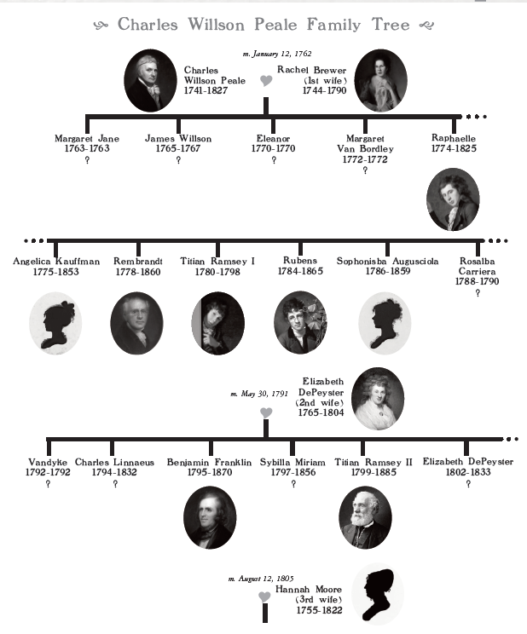

SHOW WHAT YOU KNOW

1. How old was Charles Willson Peale in 1810, when he retired to Belfield?
2. Peale moved to Belfield with his third wife and his five youngest children. Name the people that moved to Belfield in 1810.
3. Look at the names of Peale’s children. Do you recognize any of the names? Many of the children were named in honor of other great men and women. Match the Peale children’s names with their namesakes: --

Raphaelle Peale Angelica Kauffmann (Austrian painter)

Angelica Kauffmann Peale Benjamin Franklin (American scientist and inventor)

Rembrandt Peale Raphael (Italian painter)

Titian Ramsay Peale I Carl Linnaeus (Swedish naturalist)

Rubens Peale Rosalba Carreiera (Italian painter)

Sophonisba Augusciola Peale Rembrandt van Rijn (Dutch painter)

Rosalba Carriera Peale Titian (Italian painter)

Vandyke Peale Anthony van Dyke (Flemish painter)

Charles Linnaeus Peale Maria Sibylla Merian (German naturalist and illustrator) Benjamin Franklin Peale Sofonisba Anguissola (Italian painter)

Sybilla Miriam Peale Peter Paul Rubens (Flemish painter)

1. Why do you think Peale chose these names? What kind of people did he admire?

Belfield/La Salle Activity #2

**Deborah Logan’s Portrait**

Introduction:

You read about Deborah Logan and her diaries when you learned about Stenton. Deborah was a friend and neighbor of Charles Willson Peale when he lived at Belfield. In 1815, Deborah was visiting Peale and he offered to paint her portrait. We know this because she wrote about it in her diary. Deborah was 54 years old. Let’s look at a copy of her diary entry on Saturday, July 5, 1822. Below it is written out for you to read more easily.

*Today I paid C.W. Peale one hundred dollars for my Portrait, which it is my own fault is still unfinished. To say truth, tho’ like me, it is so ugly, that I feel no inclination to let Posterity think me quite so disagreeable as they unquestionably will from this picture. But the artist wanted to make up a sum of money and I very gladly paid this to him because I thought I had not done entirely well in delaying to give him an opportunity to finish his work*

When Deborah worries about “Posterity,” she means that she is worried about what people in the future (like us today!) will think about her “ugly” portrait. She feels bad that she has kept the artist waiting and unable to finish his work.

On April 28, 1825, she wrote

*I had intended going to town this morning, after so long an interval to sit again for my Portrait, which has remained so many years unfinished in my kind friend Charles Peale’s Painting Room (the fault not his but mine). The Picture is paid for, or I would not have done the good and amiable old artist injustice. Well, the rain kept me at home today*.

Deborah writes that it is her fault - not the “good and amiable” (friendly) artist’s fault – that the portrait is still not finished. It had been 3 years since she paid for it, and 10 years since Peale first offered to paint her portrait! The next day, she went to his studio to sit for the artist one final time.

On June 25, 1825 the painting was finally complete:

*Cousin brought home my picture, and advised me to burn it. She said she would not consent to go down to Posterity in such a character, or rather caricature. It does not vex me much, but to be sure it is inexpressibly Ugly. I think everyone present condemned it.*

Deborah compared the portrait to a caricature – or a cartoon. She said it did not “vex” or bother her too much, but it was definitely ugly and everyone in the room agreed. In her final entry about the painting, she wrote:

*My Portrait (looking at me) stuck over the clock in the Library is a very* ***churlish*** *thing – my kind friend and neighbor has charactered me sadly. I hope Posterity will not suppose I had such a disagreeable expression. I believe I shall be tempted*

*to put it out of the way altogether.*

Deborah hung her portrait in the library at Stenton. She writes that she has thought about “putting it out of the way” – to throw it away or get rid of it. But she did not.

In 1934, Deborah Logan’s great-granddaughter, Maria Dickinson Logan, read the diaries and made a decision. She took down the portrait and burned it in the fireplace! She believed her great-grandmother never liked the portrait anyway. So unfortunately, the original painting no longer exists. However, there is a copy of the painting which hangs at Stenton in the Blue Lodging Room today.

**Questions**

1. How much did it cost Deborah Logan to have her portrait painted?
2. How many years did it take?
3. Why do you think Deborah Logan worried about Posterity?
4. Do you think it was right or wrong for her great-granddaughter to burn Deborah Logan’s portrait? Why? What would you have done?

Belfield/La Salle Activity #3

Silhouettes

In 1802, Charles Willson Peale brought a new machine to his Philadelphia Museum. The machine was called a physiognotrace (fizz-ee-ogno- trace) for its ability to “trace” a person’s profile, and the science of “physiognomy”, which people believed explained how a person’s character or personality could be learned through their appearance, especially by looking at the face or shape of the head.

The physiognotrace was invented by John Isaac Hawkins, who gave the machine to Peale to use in his museum. A person would sit facing sideways in front of the machine. A brass pointer traced along the profile of the head as a corresponding pencil drew a smaller profile onto a paper in the machine. The paper was folded, and the profile cut out from the center with scissors, leaving a hollow-cut portrait profile in the white paper, which was then pasted onto a black background for display.

The folded paper would make four exact copies, which made it easy to share with family and friends. This kind of portrait, also called a *profile*, a *likeness,* a *shade,* or a *silhouette,* was a fast and cheap method of recording what people looked like before the invention of photography. Unlike a portrait painting, silhouettes cost only a few cents and took only a few minutes to make. 8,800 people came to Peale’s museum in 1803 for silhouettes, and Peale claimed a few years later that silhouettes could be found in “nearly every house in the United States of America.”

**Moses Williams** made many of the silhouettes at Peale’s Museum. Peale legally freed Williams from enslavement in 1803 and allowed him to continue to work at the museum for many years, earning and keeping the eight cents per silhouette fee. Williams became known for his artistic talent and skill at cutting profiles in the Philadelphia Museum.

You and your classmates can make your own silhouettes.

Materials:

* Overhead projector or large flashlight
* Pencils
* Newsprint or large paper
* Scissors
* Black paper of the same size or larger
* Masking Tape

Instructions for student led activity:

1. Follow along carefully as your teacher demonstrates how to trace the outline for a silhouette of a student, using a strong direct light (source such as an overhead projector light), a pencil, and light colored paper/newsprint paper taped to the blackboard.

2. Working in a group, decide who will pose first and who will draw. You will have 5 MINUTES to sketch the outline. Switch places so that everyone poses for a silhouette.

3. Using a pencil or pen, go over your traced outline again, so that you will be able to see the lines clearly when cutting out later on.

4. Place your silhouette over a piece of black paper and tape it to the black paper, placing a piece of tape on all 4 sides to keep in place.

5. Cut out the facial shape to make your silhouette, cutting through the newsprint and the black paper.

6. Optional: You can glue or tape your silhouette to a piece of white paper to “frame” it.

***If your class is short on time, this activity can be completed more quickly if the students line up and the teacher does the outline for each student.

Belfield/La Salle Activity #4

Looking at Portraits

 

These two portraits are hanging in the Entrance Hall of Cliveden. Do you remember seeing them on your visit? The woman in the portrait on the left is Margaret Oswald, sister of Elizabeth Oswald, the second wife of Benjamin Chew. The man in the portrait on the right is Joseph Turner, who was a prominent Philadelphia merchant and uncle of Elizabeth and Margaret Oswald.

Look carefully at the paintings to learn more about them.

1. What kind of clothing are they wearing in these paintings? Would they wear these clothes every day? Do these clothes tell you anything about the people in the portraits?
2. What objects/props do you see in the paintings? Why would the artist include these clues? Do they tell you anything about the sitter’s profession or hobbies?
3. Choose one of the portraits. If the sitter could speak to you, what do you think he or she would say?
4. Is this sitter a person you would like to meet? Why or why not?
5. Have you ever drawn a portrait of yourself? If so, what materials did you use to make your portrait? What materials do you think were used in making these portraits? What other kinds

of materials can be used to make portraits